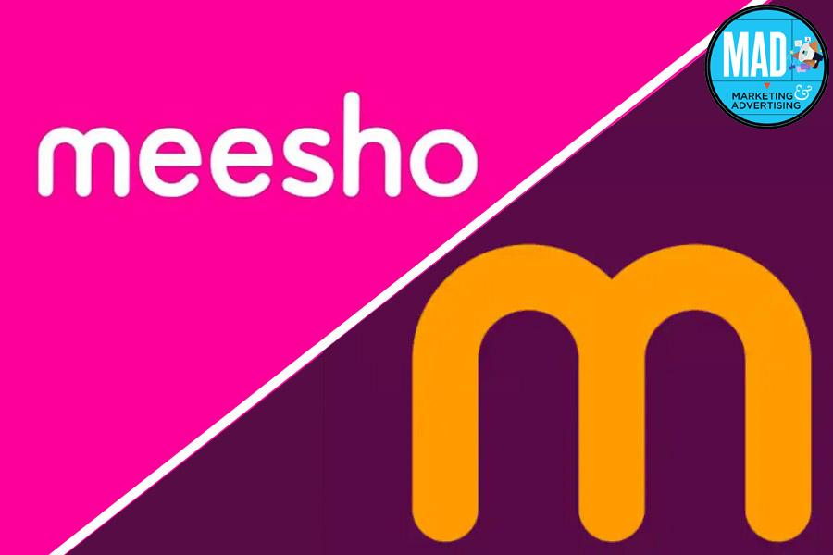

**Product Dissection For Meesho**

### **Company Overview:**

**Meesho** is an [online shopping](https://en.wikipedia.org/wiki/Online_shopping) platform belonging to the E-commerce industry.It is owned by the Indian company Fashnear Technologies Private Limited**.** It was founded inDecember 2015 By Vidit Aatrey and Sanjeev Barnwal. It is an online marketplace that facilitates trade between suppliers, resellers and customers, with heavy reliance on external social media platforms such as [Facebook](https://en.wikipedia.org/wiki/Facebook) and [Instagram](https://en.wikipedia.org/wiki/Instagram).

### **Product Dissection and Real-World Problems Solved by Meesho:**

1. **Complexity of E-commerce Setup** : Many entrepreneurs and small businesses face challenges in setting up and managing their online stores due to the complexity of e-commerce platforms and technical requirements.
2. **Lack of Technical Expertise** : Not all entrepreneurs have the technical expertise or resources to design, develop, and maintain a professional e-commerce website, leading to barriers to entry for many aspiring merchants.
3. **Limited Integration Options** : Some e-commerce platforms may offer limited integration options with third-party services and tools, restricting merchants' ability to customise and expand their online stores.
4. **High Costs and Overhead** : Traditional e-commerce solutions often involve high upfront costs, ongoing maintenance fees, and overhead expenses, making them financially prohibitive for small businesses and startups.
5. **Limited Reach**: Many businesses struggle to reach customers beyond their physical location.Meesho allows businesses to create online stores, enabling them to reach a global audience 24/7.
6. **Payment Processing**: Managing payments securely and efficiently is critical for any online business . Meesho integrates with multiple payment gateways, allowing businesses to accept various payment methods, including credit cards, PayPal, UPI and more.
7. **Inventory Management**: Keeping track of inventory levels, restocking products, and managing orders manually can be challenging and prone to error. Meesho provides inventory management tools that help businesses track stock levels, set up automatic reorder points, and sync inventory across multiple sales channels.
8. **Marketing and Sales:** Generating traffic and converting visitors into customers is a constant challenge for online businesses .Meesho offers built-in marketing tools, such as SEO optimization, email marketing, and social media integration, to help businesses attract and retain customers.

Overall, Meesho's comprehensive e-commerce platform addresses the pain points and challenges faced by entrepreneurs and businesses in setting up and managing online stores, empowering them to focus on their core business activities and achieve success

in the competitive e-commerce landscape.

### **Case Study: Real-World Problems and Instagram's Innovative Solutions**

1. **Problem** : Complexity of E-commerce Setup.

Setting up an online store can be daunting, especially for entrepreneurs without technical expertise.

**Solution**: Meesho simplifies the process with a user-friendly platform.

* Offers customizable templates and drag-and-drop interface for website design.
* Integrated payment gateways streamline payment processing.
* Built-in inventory management tools facilitate product management.

1. **Problem :** Limited Marketing and Sales Channels.

* Businesses struggle to reach customers through various marketing and sales channels

**Solution :** Meesho provides integrations with multiple channels.

* Enables selling on social media platforms, marketplaces, and physical retail locations.
* Integrates with email marketing tools, SEO optimization, and advertising platforms.
* Centralised platform for managing sales and customer interactions across channels.

1. **Problem** : Inventory Management and Order Fulfilment.

* Managing inventory and fulfilling orders efficiently is challenging, especially as businesses grow.

**Solution:**Meesho offers robust inventory management and order fulfilment feature

* Real-time inventory tracking and automated restocking prevent stockouts.
* Integration with shipping carriers for streamlined order fulfilment and tracking.
* Order management system for processing orders, managing returns, and tracking shipments.

1. **Problem:** Lack of Customization and Scalability.

* Some e-commerce platforms lack customization options and scalability, limiting business growth.

**Solution:** Meesho provides a highly customizable and scalable platform.

* Extensive ecosystem of apps, themes, and APIs for customization.
* Scalable infrastructure to support growing businesses without compromising performance.
* Flexibility to adapt and expand the online store as business needs evolve.

1. **Problem** : Data Security and Compliance.

* Protecting customer data and ensuring compliance with regulations are paramount concerns.

**Solution :** Meesho prioritises data security and compliance.

* Maintains robust security measures and compliance certifications.
* Built-in security features such as SSL encryption and fraud detection.
* Regular updates and patches to mitigate security risks and vulnerabilities.

**Conclusion:**

Meesho addresses a range of challenges faced by businesses in the e-commerce space by providing a comprehensive platform with solutions tailored to each problem area, ultimately enabling businesses to succeed and thrive in the digital marketplace.

### **Top Features of Meesho:**

1. **Product Management**: Meesho offers robust product management features, allowing merchants to easily add, edit, and organise their products as well as manage inventory and track stock levels.
2. **Payment Processing** : Meesho provides built-in payment processing through Meesho Payments as well as support for over 100 payment gateways worldwide, enabling merchants to accept payments securely and seamlessly.
3. **Order Management** : Merchants can manage orders efficiently through the Meesho order management system,which includes features such as order tracking, fulfilment, refunds, and customer communication.
4. **Marketing and SEO Tools** : Meesho offers a suite of marketing tools to help merchants attract customers including SEO optimization, social media integration, email marketing, and discounts and promotions.
5. **Security and Reliability** : Meesho prioritises security and reliability, with features such as SSL encryption, fraud detection, automatic updates,and 24/7 monitoring to protect merchants' data and transactions.
6. **Analytics and Reporting :** Shopify provides detailed analytics and reporting tools to help merchants track sales, monitor performance, and gain insights into customer behaviour, enabling data-driven decision-making.

### **Schema Description:**

**1. Users Entity :**

* **UserID (Primary Key)**: Unique identifier for each user.
* **Username**: Name of the user.
* **Email:** Email address of the user.
* **Password:** Encrypted password for user authentication.
* **RegistrationDate:** Date when the user registered on the platform.
* **UserType:** Type of user (e.g., customer, admin).

**2. Products Entity :**

* **ProductID (Primary Key):** Unique identifier for each product.
* **ProductName:** Name of the product.
* **Description:** Description of the product.
* **Price:** Price of the product.
* **Quantity:** Available quantity of the product in stock.
* **CategoryID (Foreign Key):** Reference to the category the product belongs to.

**3. Categories Entity :**

* **CategoryID (Primary Key):** Unique identifier for each category.
* **CategoryName:** Name of the category.

**4. Orders Entity :**

* **OrderID (Primary Key):** Unique identifier for each order.
* **UserID (Foreign Key):** Reference to the user who placed the order.
* **OrderDate:** Date when the order was placed.
* **TotalAmount:** Total amount of the order.
* **OrderStatus:** Status of the order (e.g., pending, fulfilled, cancelled).

**5. Order Items Entity :**

* **OrderItemID (Primary Key):** Unique identifier for each order item.
* **OrderID (Foreign Key):** Reference to the order the item belongs to.
* **ProductID (Foreign Key):** Reference to the product in the order.
* **Quantity:** Quantity of the product ordered.
* **UnitPrice**: Unit price of the product at the time of order.

**6. Payments Entity :**

* **PaymentID (Primary Key):** Unique identifier for each payment.
* **OrderID (Foreign Key):** Reference to the order for which the payment was made.
* **PaymentDate:** Date when the payment was made.
* **Amount**: Amount paid for the order.
* **PaymentMethod:** Method used for payment (e.g., credit card, PayPal).

**7. Reviews Entity :**

* **ReviewID (Primary Key)**: Unique identifier for each review.
* **UserID (Foreign Key):** Reference to the user who wrote the review.
* **ProductID (Foreign Key):** Reference to the product being reviewed.
* **Rating:** Rating given by the user for the product (e.g., on a scale of 1 to 5).
* **Comment:** Optional comment provided by the user.

**8. Shipping Entity :**

* **ShippingID (Primary Key):** Unique identifier for each shipment.
* **OrderID (Foreign Key):** Reference to the order for which the shipment was made.
* **ShippingDate:** Date when the shipment was dispatched.
* **TrackingNumber:** Tracking number for the shipment.
* **ShippingStatus:** Status of the shipment (e.g., shipped, out for delivery).

**Relationships are :**

1. **Users Table (One-to-Many with Orders Table) :**

Each user can have multiple orders, but each order belongs to only one user.This relationship is established through the UserID column in the Orders Table,which acts as a foreign key referencing the UserID column in the Users Table.

1. **Orders Table (One-to-Many with OrderItems, Payments, and Shipping Tables) :**

Each order can have multiple order items, payments, and shipments associated with it, but each order item, payment, and shipment belongs to only one order.This relationship is established through the OrderID column in the OrderItems, Payments, and Shipping Tables, which act as foreign keys referencing the OrderID column in the Orders Table.

1. **Products Table (One-to-Many with OrderItems Table and Many-to-One with Categories Table) :**

This relationship is established through the ProductID column in the OrderItems Table, which acts as a foreign key referencing the ProductID column in the Products Table.

Each product belongs to one category, but each category can have multiple products. This relationship is established through the CategoryID column in the Products Table, which acts as a foreign key referencing the CategoryID column in the Categories Table .

1. **Reviews Table (One-to-Many with Users and Products Tables) :**

This relationship is established through the UserID and ProductID columns in the Reviews Table, which act as foreign keys referencing the UserID column in the Users Table and the ProductID column in the Products Table, respectively.

**ER Diagram:**

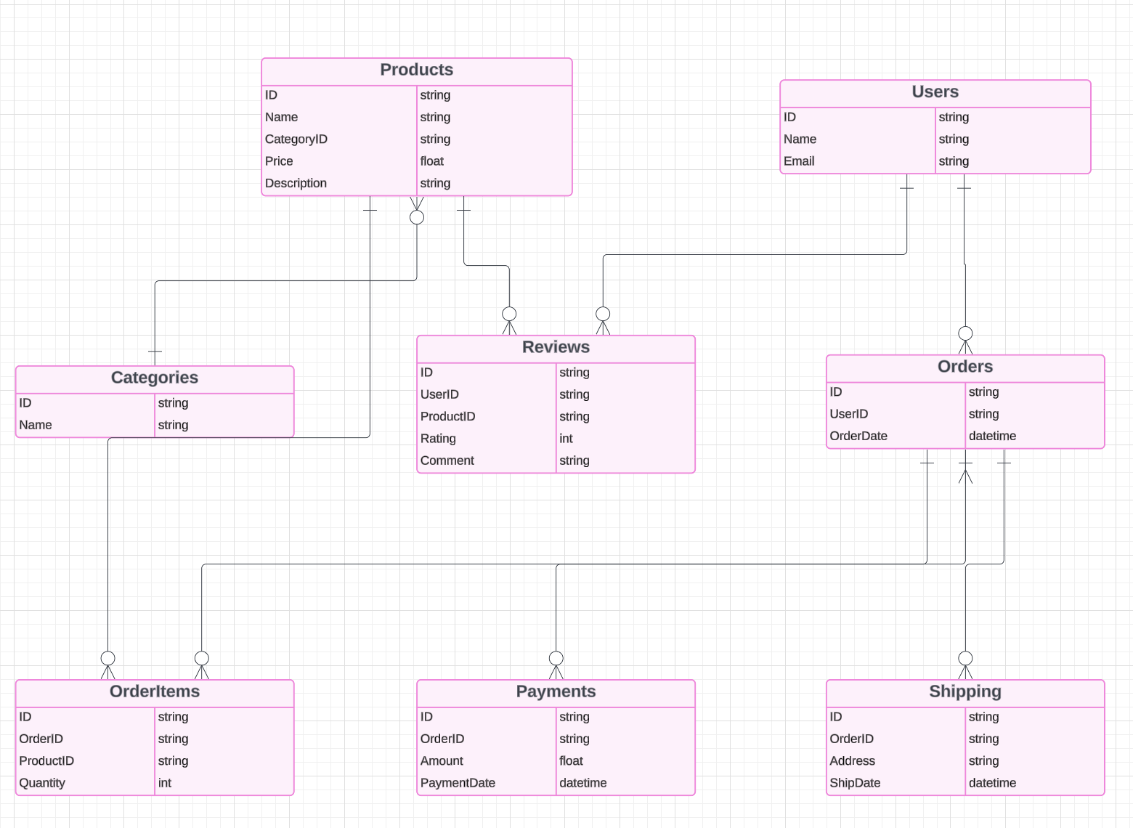

### **Conclusion:**

In this case study, we delved into the design of Meesho schema and Entity-Relationship diagram. Meesho has revolutionised the way people engage with online Shopping from e-commerce sites. The platform's intricate data model, consisting of entities like Product,Categories, user , Review, order, orderitem, payments and shippings, forms the foundation for its seamless functionality. By understanding this schema, we gain insight into how Meesho effectively manages the complexities of merchants' interactions and product description ,user experience, contributing to its widespread popularity and continued growth in the world of E–commerce.